Robert Poppit (1774-1838) was baptized in Hissington[1] and lived his whole life in and around Hyssington, where he was a coal miner.[2]

From PSkellon: Robert’s line can be traced back to a Robert Popitt[3] who was born about 1670 in the Minsterley valley, which runs SW from Shrewsbury, Shropshire[4] (where Robert Popitt was born) to the Welsh border in Montgomeryshire. This valley has been used for lead mining since Roman times.[5] The Poppett men were miners until the late 19th century. Poppitts were churchwardens at St Ethelreadas church in Hyssington[6] and worked the nearby barytes (barium) mines on Corndon Hill[7], known as White Grit, since its use as white pigment in paint prior to titanium dioxide.

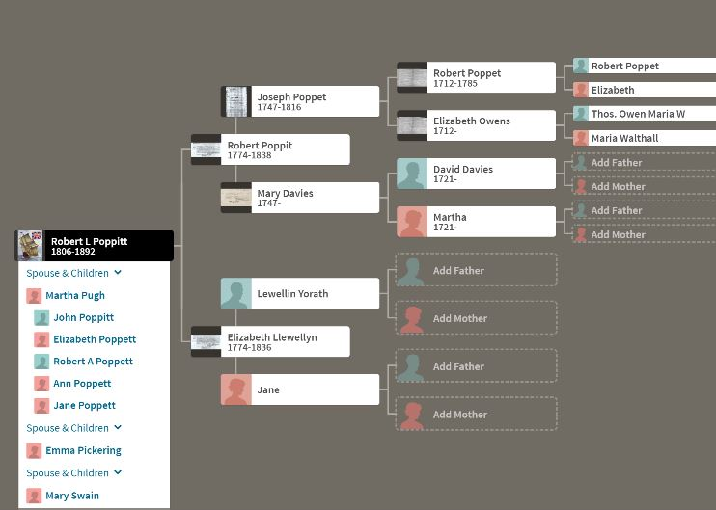

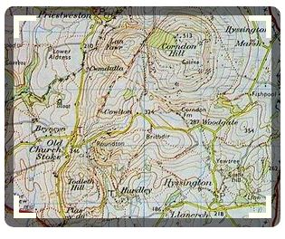source: BBC website

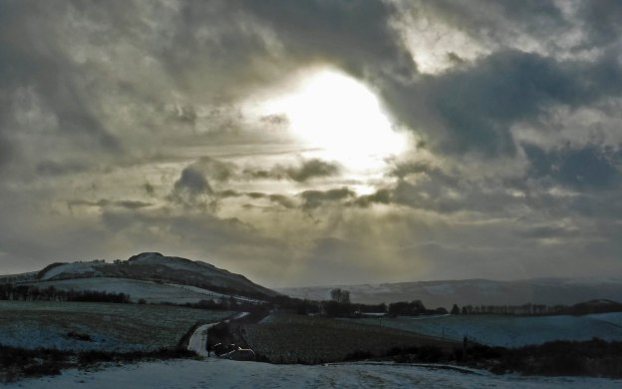Big Grit [8]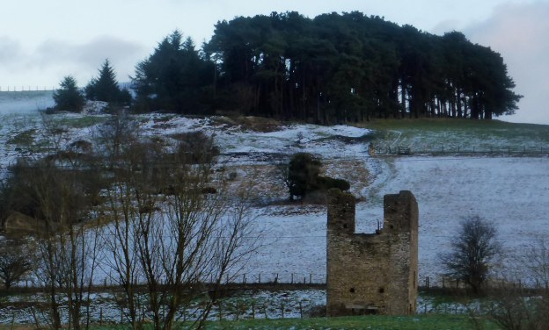White Grit Engine Shaft[9]

Around 1800 the branch including our shared ancestor, Robert Popitt’s father Joseph Poppit, moved to the East Shropshire coalfield around Donnington & Lilleshall[10]. Joseph was a Charter Master (gang boss) responsible to the owner for running the mine. His gravestone and several other family ones are still visible leaning against the church wall in Lilleshall.[11][12]

RLP’s mother Elizabeth Llewellyn died in 1836 and his father Robert Poppit died in 1838[13].

1. England, Select Births and Christenings, 1538-1975
2. Peter Skellon
3. Per Peter (pskellon): “I am stymied for any records going back from 1670 but intriguingly there is mention of a Rafe Popet in Ludlow in the 1500s”
4. http://www.genuki.org.uk/big/eng/SAL/Shropshire/ShropshireGaz1831L
5.
6. <http://www.bbc.co.uk/history/domesday/dblock/GB-328000-294000/page/9>; need to search for records there
7. <http://www.stiperstonesandcorndon.co.uk/the-scheme-area/geology/>; <http://shropshirehistory.com/mining/sshropsof.htm>

   http://fell-finder.blogspot.com/2012/10/corndon-hill-and-stiperstones-shropshire.html
8. https://shropshireblues.wordpress.com/tag/white-grit/
9. https://shropshireblues.wordpress.com/tag/white-grit/
10. http://www.bbc.co.uk/shropshire/content/articles/2005/07/12/nature_corndon_hill_feature.shtml
11. Peter Skellon
12. Christine Thomas: Jul 10, 2015 “A few weeks ago I went to Churchstoke and Hyssington to see if there were any gravestones for the Poppetts but I couldn’t find any.”
13. Copy of death certificate and burial registry in his profile; hers are likely in Chris099’s tree